Confirmbox

confirm("Are you sure?");

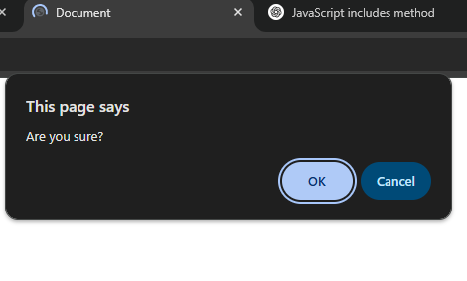

var a = confirm("Are you sure?");
alert(a);
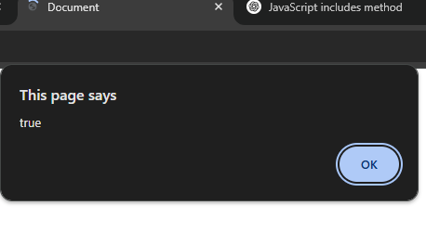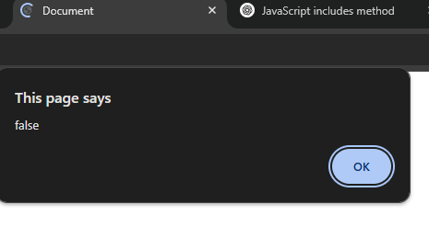

in alert true will show if we press “ok” in Confirmbox and Flase for cancel

Prompt
var a = prompt("your age?");
alert(a);

